Problem Statement or Requirement:
A requirement from the Hospital, Management asked us to create a predictive model which will predict the Chronic Kidney Disease (CKD) based on the several parameters. The Client has provided the dataset of the same.
- Identify your problem statement :
Prediction of categorical data CKD – Stage 1 – Machine Learning
Stage 2 – Supervised learning.(both input /output is given, clear requirement)
Stage 3- Classification (when predicting data is categorical data).
- Tell basic info about the dataset: Rows: 399, Columns: 28
- Mention the pre-processing method if you’re doing any :
- Few Columns were nominal data so converted it into numerical fields using get_dummies()
- Also using preprocessing technique standardscaler to increase the model performance as well to convert into defined values
Screenshots:
SVM:
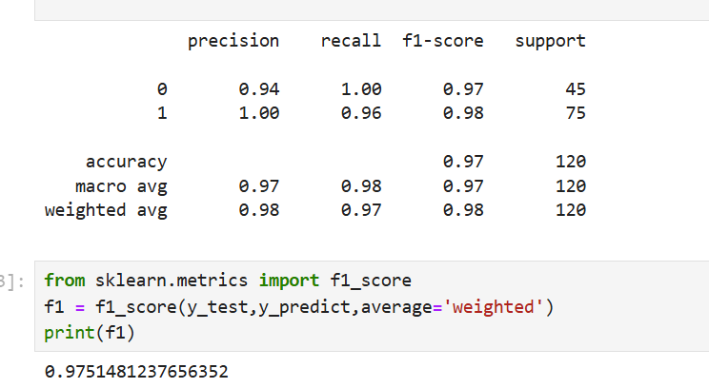

Random forest:
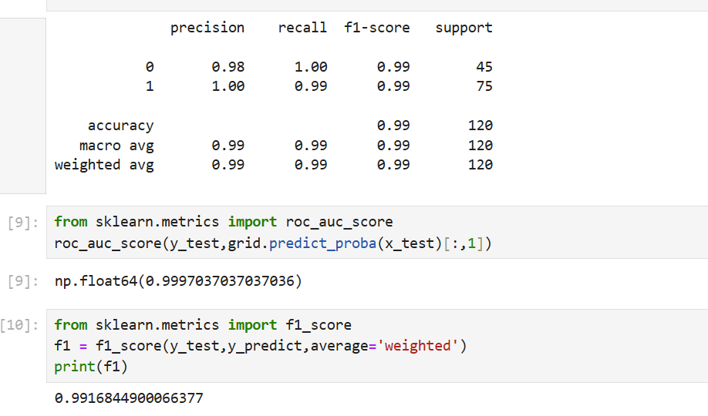

Decision Tree: 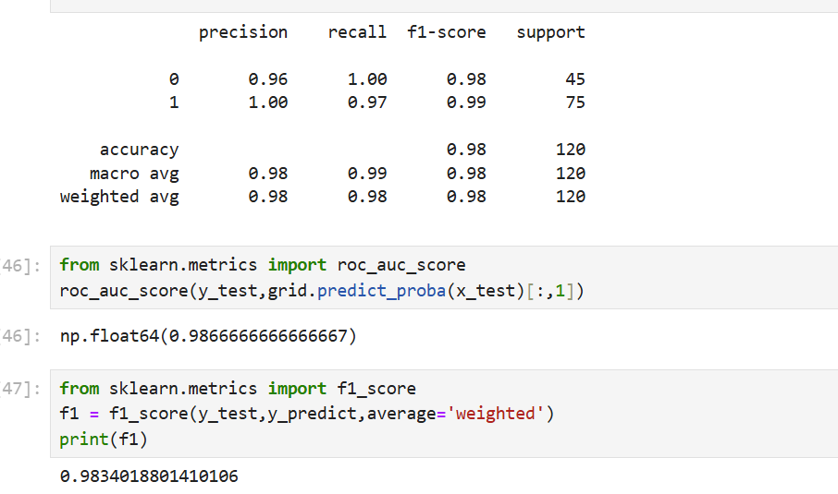

Logistic Algorithm:
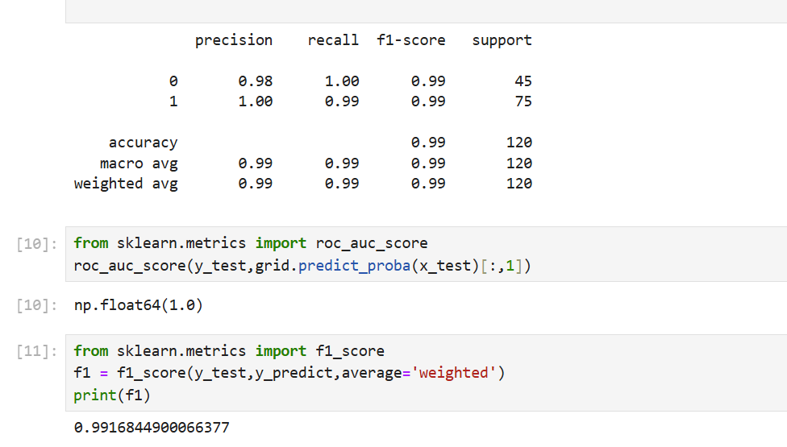

KNN:

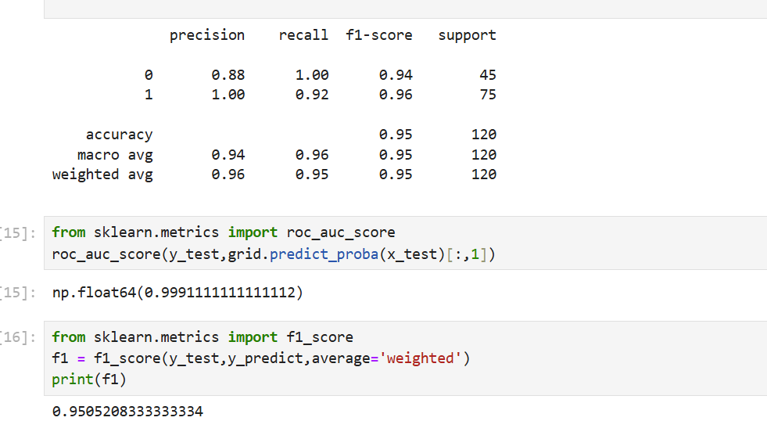

Naives Bayes:

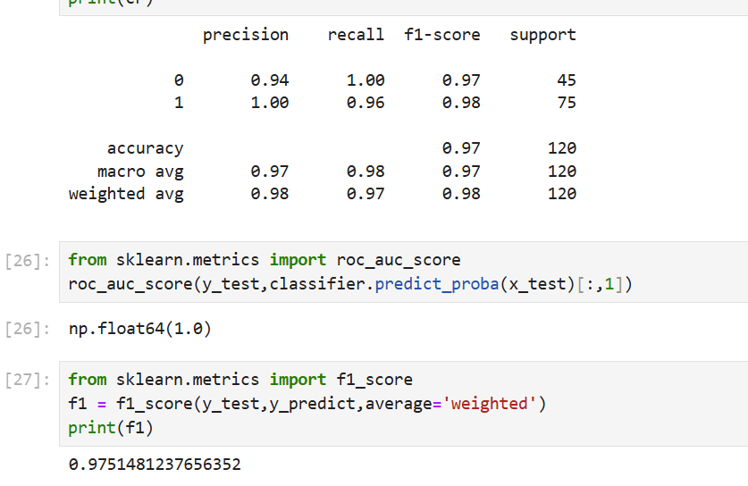

LogisticRegression and Randomforest yields almost same predictions but at the end when we try all possible ways to evaluate the metrics using ROC_AUC_SCORE LogisticRegression wins.

Hence Final model is Logistic Regression.

